**Nikau Washes his Hands**

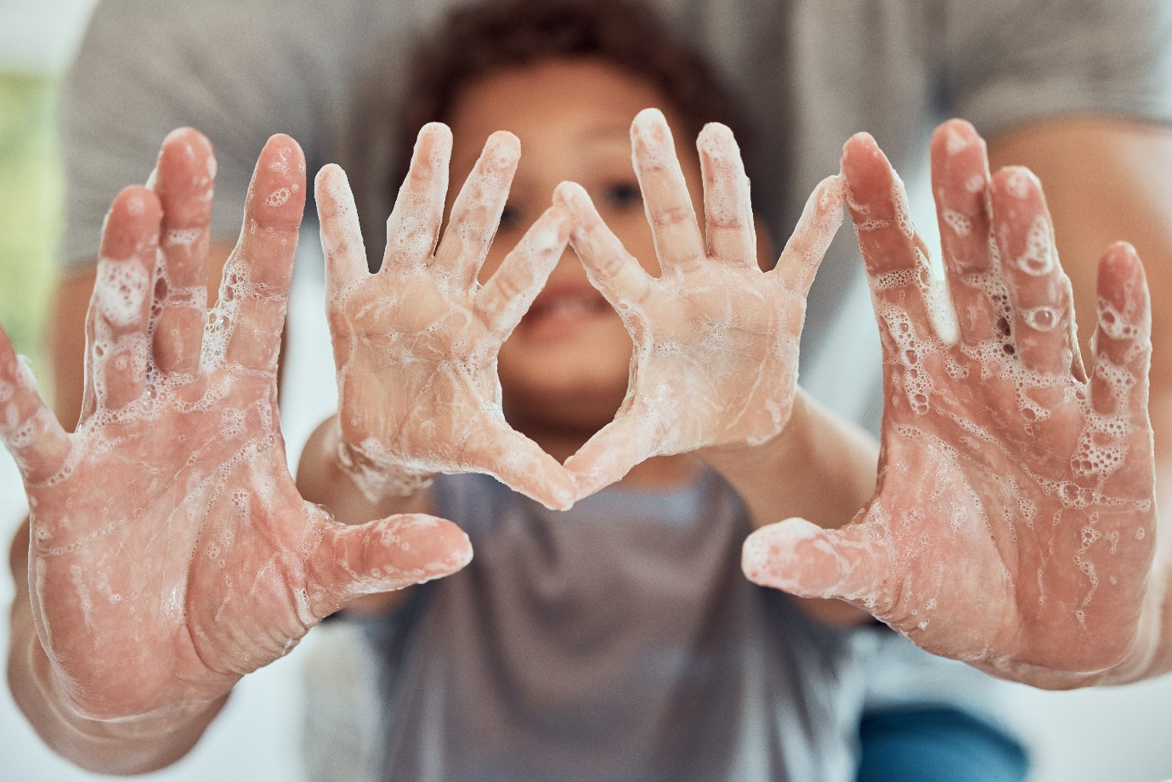

It is time to eat

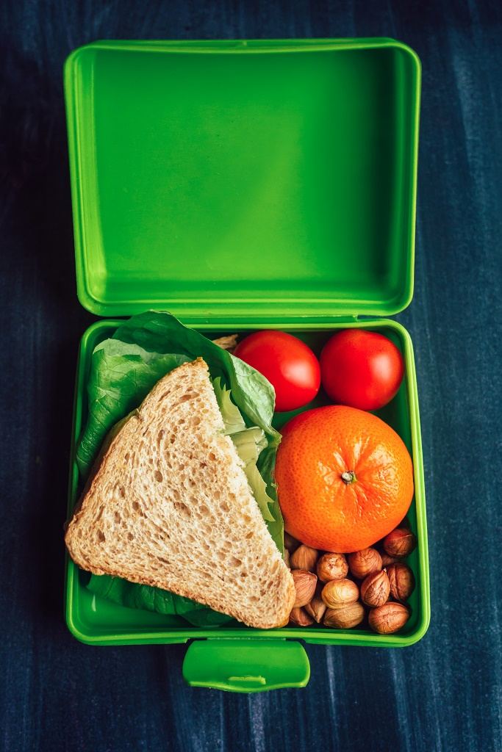

I need to wash my hands before I eat

I turn on the tap and wet my hands

I put soap on my hands

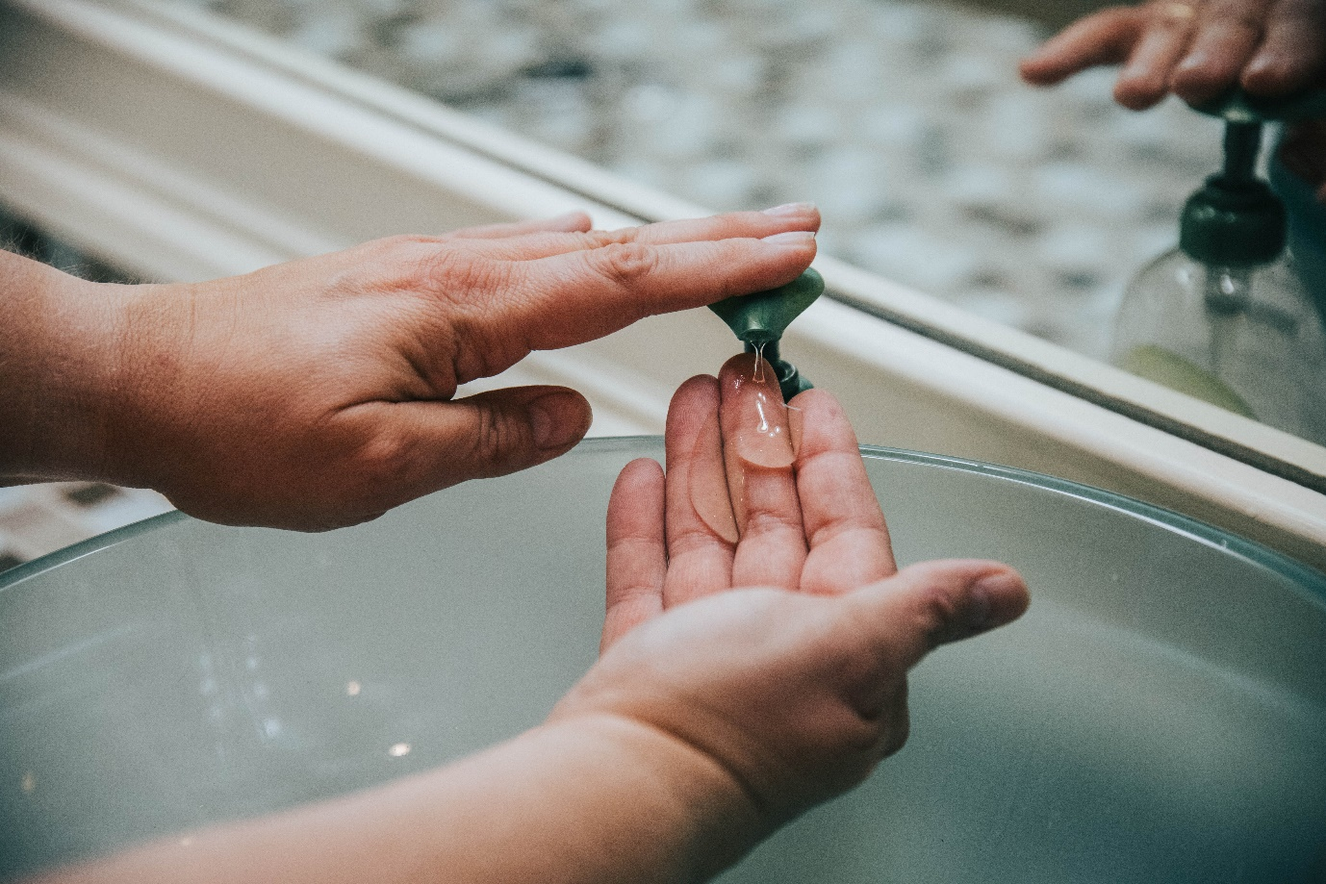

I rub my hands together until we count to 10

I wash off the soap under the water

I turn off the tap

I dry my hands

When my hands are clean, then I can eat